https://mizitechinfo.wordpress.com/2014/11/17/simple-step-deploying-software-using-group-policy-in-windows-server-2012-r2/

**Simple Step : Deploying Software using Group Policy in Windows Server 2012 R2**

November 17, 2014

Windows Server 2012 R2 includes a feature called**Software Installation and Maintenance** that AD DS, Group  
Policy, and the Windows Installer service use to install, maintain, and remove software from your  
organization’s computers.

In this post this time, lets go through a simple step how we can **deploy software to our infrastructure using GPO**.

For this demo, i will be using **Adobe Reader X** as my application.

1 – In your Domain Server, open Server Manager, click Tools and open Group Policy Management…

– In the Group Policy Management console, right click domain name which is osi.com.my, and click Create a GPO in this domain, and link it here…

**[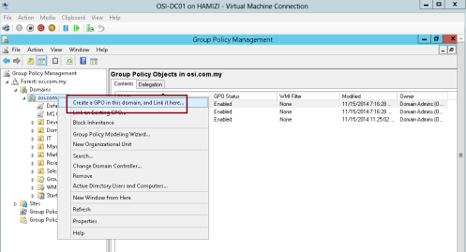](https://mizitechinfo.files.wordpress.com/2014/11/17.png)**

2 – In the New GPO box, in the Name box, type Deploy Adobe Reader, and then click OK…

**[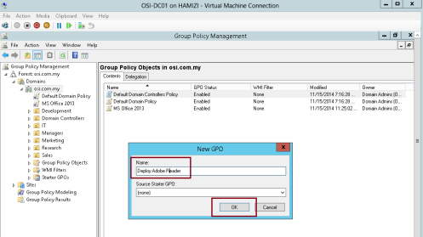](https://mizitechinfo.files.wordpress.com/2014/11/22.png)**

3 – Next, on the Group Policy Management console, right click Deploy Adobe Reader GPO and click Edit…

**[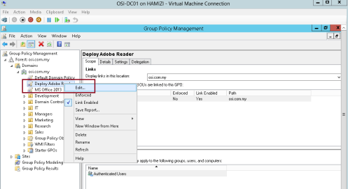](https://mizitechinfo.files.wordpress.com/2014/11/32.png)**

4 – In the Group Policy Management Editor, under Computer Configuration, expand Policies, and  
then expand Software Settings.

– Right-click Software installation. From the context menu, click New, and then click Package…

**[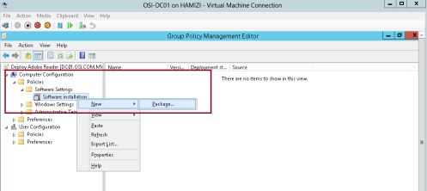](https://mizitechinfo.files.wordpress.com/2014/11/42.png)**

5 – In the Open dialog box, browse to \\dc01\Adobe, click AdbeRdr1000_en_US.msi, and then click  
Open.

**[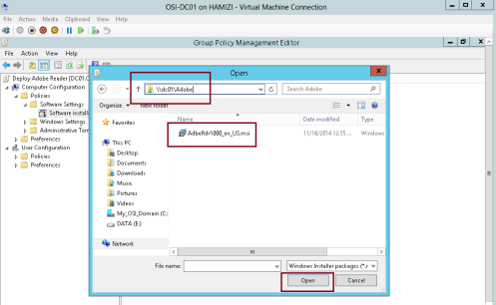](https://mizitechinfo.files.wordpress.com/2014/11/52.png)**

6 – In the Deploy Software window, ensure that the Assigned option is selected, and then click OK…

**[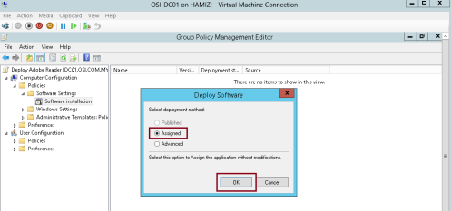](https://mizitechinfo.files.wordpress.com/2014/11/62.png)**

7 – Wait for few second and verify that the Adobe ReaderX is listed in the Group Policy Management Editor…

**[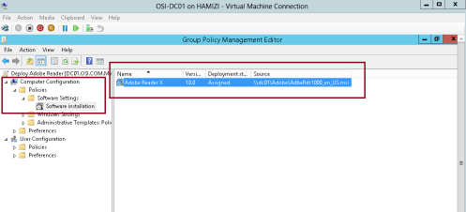](https://mizitechinfo.files.wordpress.com/2014/11/72.png)**

8 – Now lets switch to our Windows 8.1 client PC, i do recommend that you run gpupdate /boot /force in the client PC and then restart the client PC.

— after restarting your client PC and log in as domain user, you can verify that Adobe is installed.

**[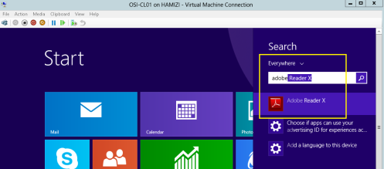](https://mizitechinfo.files.wordpress.com/2014/11/82.png)**

That’s all for now.. i will continue later with Configuring Folder Redirection in Windows Server 2012 R2…